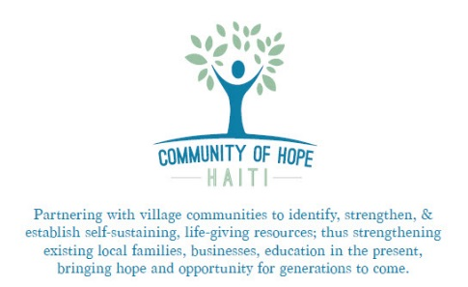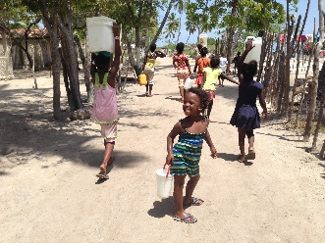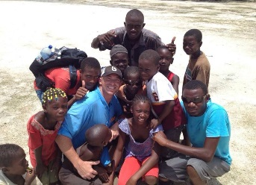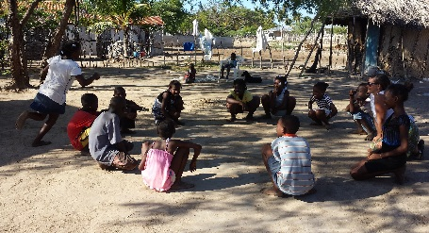
Planning for Your Trip to Haiti

“How beautiful are the feet of those who bring good news!” – Isaiah 52:7. We are so excited to partner with you for the sake of laboring together for the glory of God! We are confident that God will use you in ways you never imagined possible; as well as speak to you in ways you’ve never experienced.

We want to ensure that your journey is a great success. We’ve put together a list that will help you prepare for your journey. NOTE: We are the only mission in our area for a reason. You are coming to a beautiful, but difficult place due to living conditions. Peoples’ hearts are wide open to receive the love of Jesus. The people are amazing. The living conditions are not. Your personal safety is not an issue at all. Your “flesh” (your personal comforts), however, will be challenged. We encourage you to research Haiti before you come. If you have never been before it will be a big culture shock and your emotions will be in many different places, so keep that in mind. The mainland is busy, but our village is not. Most of the country is very poor, however you will be faced with extensive poverty continually when you are in our village. Please talk to us if you want to reach out to a certain family, person or child. Every story is different, so is each specific heart need. Remember that Jesus said to leave the 99 for the 1, which means he knows the specific needs of each person.

What to Expect

Grand Vide, Haiti is on western side of the island of La Gonave (38 miles long by 8 miles wide). We are 31 miles from mainland Haiti across the Canal de Sud. Our village of 1800 is on the Caribbean Sea. We walk almost everywhere, as there are no cars. There is no electricity; but we have solar panels – to charge your electronics, make cold water, & provide lights. There is no indoor plumbing; but we have latrine-style toilets, bucket showers (cold water – it feels great!), & filtered water to drink. COHH has two (2) homes.
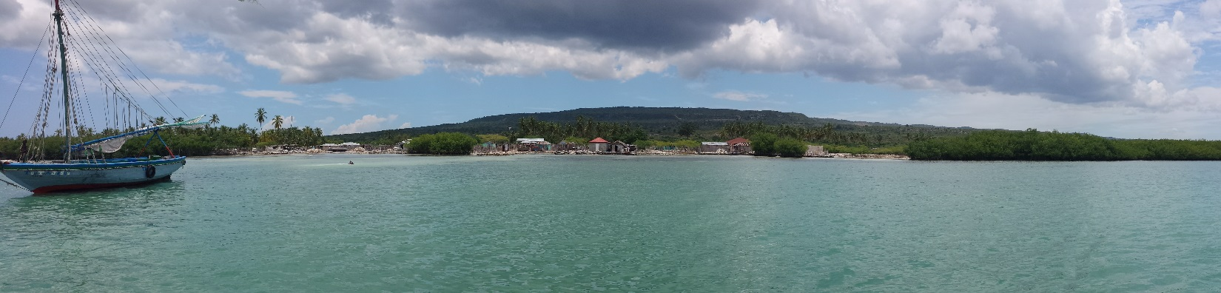

- Food: The food is excellent! We eat a lot of rice & beans. Fresh fish (small fish, snapper, mahi, conch, lobster), chicken, & goat are on the menu regularly. Fresh bread, avacados, coconuts, plantains, melon, & corn, as well. Please let us know if you have any dietary restrictions.
- Travel: We will take a 1 hour bus ride from PAP Airport to Leogane, where we will stay overnight. We will then take another 1 hour bus ride to Miragoane, where we will take a boat for 3 hours. On the island, we will walk most places. We will take a short boat ride to a beach.
- Climate: We are in the Caribbean. Temperature: 86-94 day, 72-82 night. Sunny 99% of the time.
- Sleeping: A fan will help you greatly! Bunk-style beds. One queen bed for married couples.
- People: The people will love you; especially the kids. They speak Creole. We will have translators for you. We have established a very healthy relationship with the people. You will be very safe.

Before you Come
- Vaccinations – CDC recommends several vaccinations prior to traveling to Haiti. http://www.cdc.gov/globalhealth/countries/haiti/ We have found Hepatitis series, tetanus, & typhoid (the pill form, if you can find it) to be the most important vaccinations (especially if you’re medically-inclined).
- Passport
- Pray – a LOT! If you’re coming with a team, get together & pray. Pray for unity, for The Holy Spirit to go before you & prepare the way. If you have anything in your life that’s not right with God, now’s a good time to give it over to Him. If you fast, fast. If you take this trip seriously for the Kingdom of God, He WILL answer our asking Him “Your kingdom come, your will be done - here on earth as it already is in heaven”. We’re seeing it! We need more. Other suggestions to pray: Malachi 4:5-6. Isaiah 60. Ezekiel 36. Ephesians 1:17-19. Matthew 9:37-38. Ephesians 3:16-19.

What to Bring
- Bible, journal stuff
- Medications:
Dramamine (non-drowsy), Bactrim Forte (travelers’ diarrhea)
- Toiletries:
Baby wipes, toilet paper
Hand Sanitizer
Sunscreen (a lot of it), Chapstick
Towel, soap/shampoo, washcloth – 2 (good for sweat, too)
Bug Spray (we have No See Um’s, some mosquitos…not a lot)
- Clothing: (Light colors, light materials)
Church: men: pants & collar shirt. Women: long(er) skirt or pants.
Shoes: Sandals, tennis shoes with good support
Sunglasses
Hat
Swimsuit, rash guard, snorkel stuff (we have incredible reefs)
- Sleeping: Fan (recommend rechargeable fans: The Ryobi from Home Depot is PHENOMENAL!!! It is $39 + battery, but it’s worth it for a good nights’ sleep!) or a $5-$10 battery operated from Wal-Mart works okay.
Mosquito Net
Ear Plugs
Single Bed Sheet & Pillow
WATER BOTTLE
- Money: You can buy cold sodas, snacks, coconuts, fish, etc. from the village. We can exchange the money for goudes in Port-Au-Prince.
- Snacks: Beef jerky, CLIF bars, Mio, trail mix, dried fruit, protein powder
- Optional Items: (Ministry ideas in the village – these are only ideas) – we can discuss this before you come, as we can pray & hear together what The Lord wants to do.
Childrens ministry tools (skit materials)
Musical Instruments (We have 2 guitars, 1 keyboard now)
Fishing Tackle (braided line, hooks, wire leader, weights, salt water lures)
Soccer stuff (balls, jerseys, shoes, flags, cones)
Medical stuff (sutures, betadine, eye drops,
Agricultural stuff (organic seeds, pre-packaged starter seed pots with soil in them)
Bibles – in Creole, French
Toothbrushes, toothpaste, soap
Sugar-free candy (for kids – so we do not contribute to tooth decay…big problem!)

** Drink LOTS of water before you come; the boat ride will seem long and the sun is hot. Boat ride day: drink water in the morning, but not much. Women wear skirts. Unfortunately, there is not always a bathroom available. We have had to use a private spot on the street to go.

WE will be praying for each of you and your trip. Please continue to pray for us; the battle is real! We very much look forward to serving Jesus together! What a blessing!!

The Tucker Family
Community of Hope Haiti
brian@communityofhopehaiti.org
www.communityofhopehaiti.org
www.facebook.com/communityofhopehaiti
